**EET 1140**

|  |  |  |
| --- | --- | --- |
| **1.** | **LAB NUMBER:** | **7** |
| **2.** | **TITLE:** | **Mesh (Loop) Circuit Analysis** |
| **3.** | **OBJECTIVES:** |  |

After completing this lab, the student will be able to:

a. verify the validity of the Mesh (Loop) method,

b. measure the voltage drops at various points of the circuit,

c. verify Kirchhoff’s Voltage Law for each Loop, d. measure the source and branch currents,

e. verify Kirchhoff’s Current Law.

**4. EQUIPMENT:**

DC Power Supply: Uni PS-2303

Digital Multimeter: RIGOL DM 3058E

Experimenter board (C.A.D.E.T.) or a Breadboard

Multisim Software

**5. COMPONENTS:**

1 - 470 Ω ½ watt 5% Resistor

1 - 510 Ω ½ watt 5% Resistor

1 - 620 Ω ½ watt 5% Resistor

1 – 1k Ω ½ watt 5% Resistor

1 - 2k Ω ½ watt 5% Resistor

**6. TEXT REFERENCE:**

Circuit Analysis: Theory and Practice (5th Edition): A.H. Robbins and W.C. Miller

Section 2.6: Measuring Voltage and Current

Section 3.7: Measuring Resistance – the Ohmmeter

Section 8.5: Mesh (Loop) Analysis

**7. PRE-LAB ASSIGNMENT:**

Study Fig. 1 and do the following calculations:

(Attach all your calculations at the end of your report as an Appendix)

Figure 1:

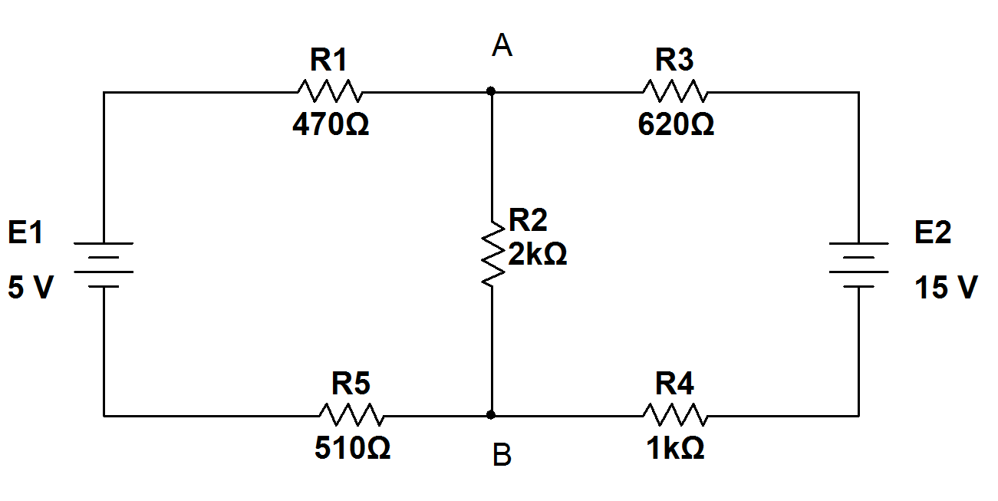

I1 I2



Table 1:

I1 = -1.911 mA I2 = -5.527 mA

1. Use Loop analysis to determine the values of 2 loop currents I1 and I2 (running clockwise). Record your answers in Table 1. Write down the signs of the currents.
2. From I1 and I2 determine the currents through each resistor. Record your results (magnitude and sign) in Table 2.

Table 2:

|  |
| --- |
| IR1 (=I1) = -1.911 mA |
| IR2 (=I1-I2) = 3.616 mA |
| IR3 (=I2) = -5.527 mA |
| IR4 (=I2) = -5.527 mA |
| IR5 (=I1) = -1.911 mA |

1. A negative sign indicates that the actual current is opposite to the assigned direction. *Mark the direction of the actual current through each resistor in Fig. 1*
2. From these currents, calculate the voltage drop across each resistor and *mark its polarity in Fig. 1*. Record your results in Table 3

Table 3:

|  |
| --- |
| VR1 = -0.898 V |
| VR2 = 7.232 V |
| VR3 = -3.426 V |
| VR4 = -5.527 V |
| VR5 = -0.974 V |

**8. MEASUREMENTS:**

**A – Measuring Voltage:**

a) Built the circuit of Fig. 1, built the resistor network first then locate and connect the **fixed 5V** and **15V** sources on the DC power supply.

b) Set the DMM to measure voltage then measure the voltages of the sources and all resistors. Note the polarity of these voltages to see if they agree with what you marked in part d (Pre-lab) above. Record your results in Table 4.

Table 4:

|  |
| --- |
| E1 = V |
| E2 = V |
| VR1 = V |
| VR2 = V |
| VR3 = V |
| VR4 = V |
| VR5 = V |

c) Compare Table 4 to Table 3.

**B – Measuring Current:**

d) Set the DMM to measure current then measure the currents through all resistors. Note the directions of these currents to see if they agree with what you marked in Fig. 1. Record your results in Table 5.

Table 5:

|  |
| --- |
| Ir1 = mA |
| Ir2 = mA |
| Ir3 = mA |
| Ir4 = mA |
| Ir5 = mA |

e) Compare Table 5 to Table 2.

f) Verify Kirchhoff’s Voltage Law in Loop 1 (use clockwise direction). g) Verify Kirchhoff’s Voltage Law in Loop 2 (use clockwise direction).

h) Verify Kirchhoff’s Current Law at node A, using actual current directions and data in Table 5.

1. Verify Kirchhoff’s Current Law at node B, using actual current directions and data in Table 5.

**C – Multisim Simulations:**

j) Create a Multisim circuit (similar to Fig. 1) with:

1. Voltmeters to measure sources and resistors voltages.
2. Ammeters to measure 5 resistors’ currents.

**9. LAB REPORT REQUIREMENT:**

Your team’s Lab Report should contain the followings:

**A Cover Page** with Lab Number, Lab Title, Team members’ Names and Date.

**Result Pages** with:

**A - Voltage Measurements:**

Results:

Show a copy of Table 4

Discussions:

1. Answer 8(c) with Multisim voltages.
2. What causes the differences in results.

**B - Current Measurements:**

Results:

Show a copy of Table 5

Discussions:

1. Answer 8(e) with Multisim currents.
2. Show the results of 8 (f, g, h, i).

**C - Conclusion:** (*it helps to compare your prelab with measured results*)

1- What conclusion can you make about KVL for this circuit?

2- What conclusion can you make about KCL for this circuit?

3- What conclusion can you make about the validity of the Mesh (Loop)

method of analysis? Explain your answer.

4- Are all the Lab objectives met? Explain if some are not.

**Appendix:** Attach a printout of **Multisim** simulation and all **Pre-Lab calculations**.

**Circuit Layout**

